**Azure Data Factory (ADF)** is a cloud-based data integration service provided by Microsoft Azure. It enables you to create, schedule, and manage data workflows that move and transform data from various sources to different destinations. Azure Data Factory is a fully managed service, meaning that Microsoft handles the underlying infrastructure, scalability, and maintenance, allowing users to focus on building and managing their data pipelines.

One of the key components of Azure Data Factory is the **Copy Activity**. The Copy Activity is used to move data between different data stores. It supports a wide range of source and destination data stores, including Azure Blob Storage, Azure Data Lake Storage, Azure SQL Database, Azure Synapse Analytics and many more. With Copy Activity, you can perform various data movement operations, such as:

1. **Data Ingestion**: Copy data from source data stores to Azure or other cloud platforms for further processing and analysis. This could involve moving data from on-premises databases, files, or cloud-based applications.
2. **Data Loading**: Load data into data warehouses or data lakes for storage and analysis. This could involve loading data into Azure Synapse Analytics, Azure SQL Data Warehouse, or Azure Data Lake Storage.
3. **Data Replication**: Replicate data between different data stores to maintain data consistency across multiple environments or regions.
4. **Data Migration**: Migrate data from on-premises data stores to the cloud or between different cloud platforms.

The steps to perform the copy activities in Azure Datafactory (ADF) are as follows:

**Step-1**: We need to create a 2 separate storage account (one for source where we need to keep a file or application in it and another one is for destination where we need to move the file or application from the source storage to the destination storage). We can use **Azure Blob Storage** or **Azure Datalake Gen 2**. But for now, we will use Azure Blob Storage for both storage accounts. The below image shows us the 2 Azure Blob Storage account.

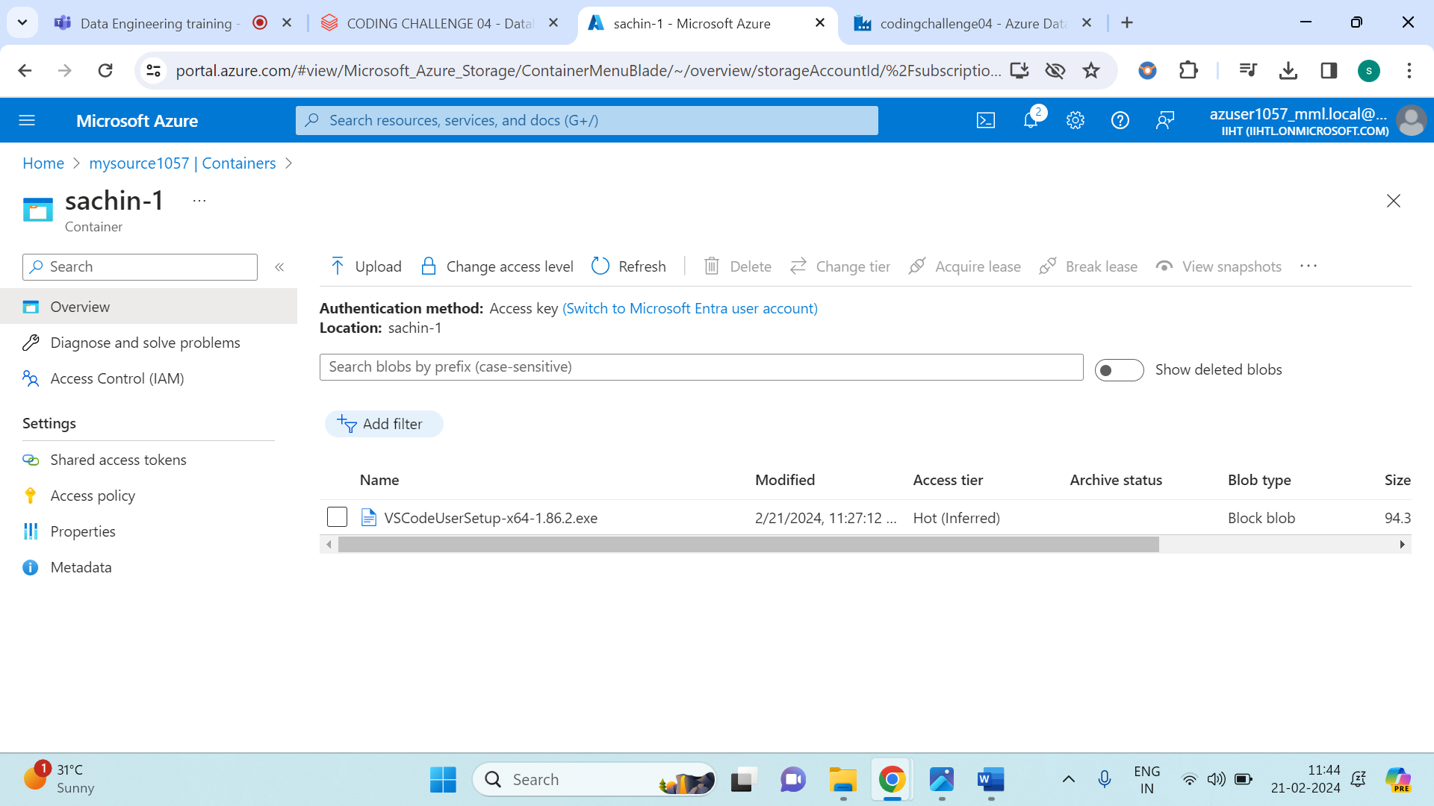

The above image shows us that i have created an initial account named **mysource1057** storage account and i have created a container named **sachin-1** and inserted two applications.

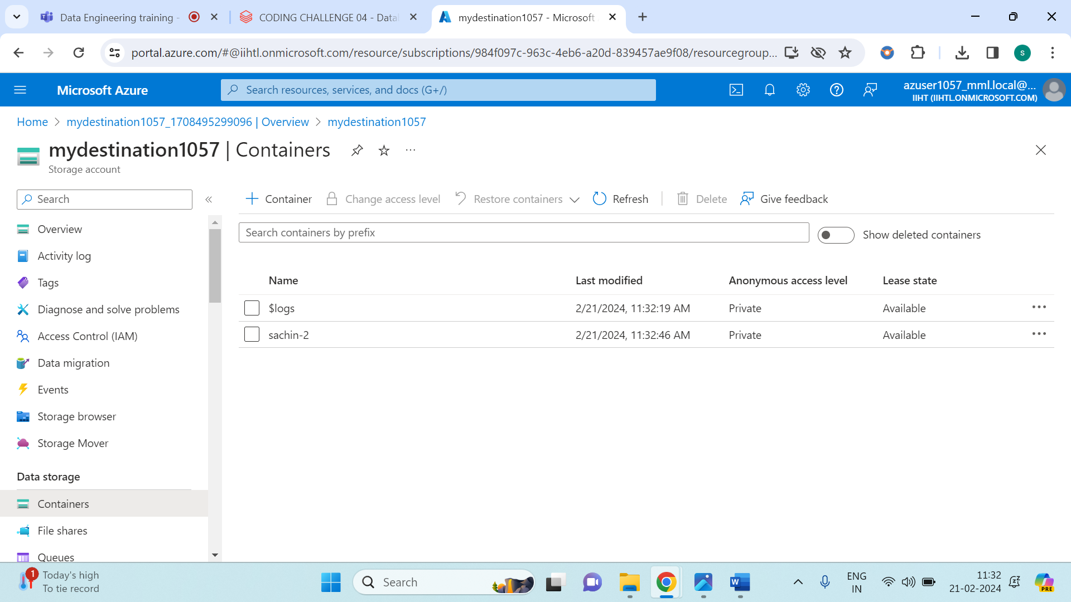

The above image shows us, that I have created another storage account named **mydestination1057** account and I have created a container named **sachin-2** and it is empty (since, we needed to copy the data from the source to the destination).

Once we have created 2 storage account, the later steps is to create a Azure Datafactory. Once we have created the azure datafactory we need to click ‘Go to resource’ and the we need to click ‘Launch studio’. After following these you need to get this interface as shown below.

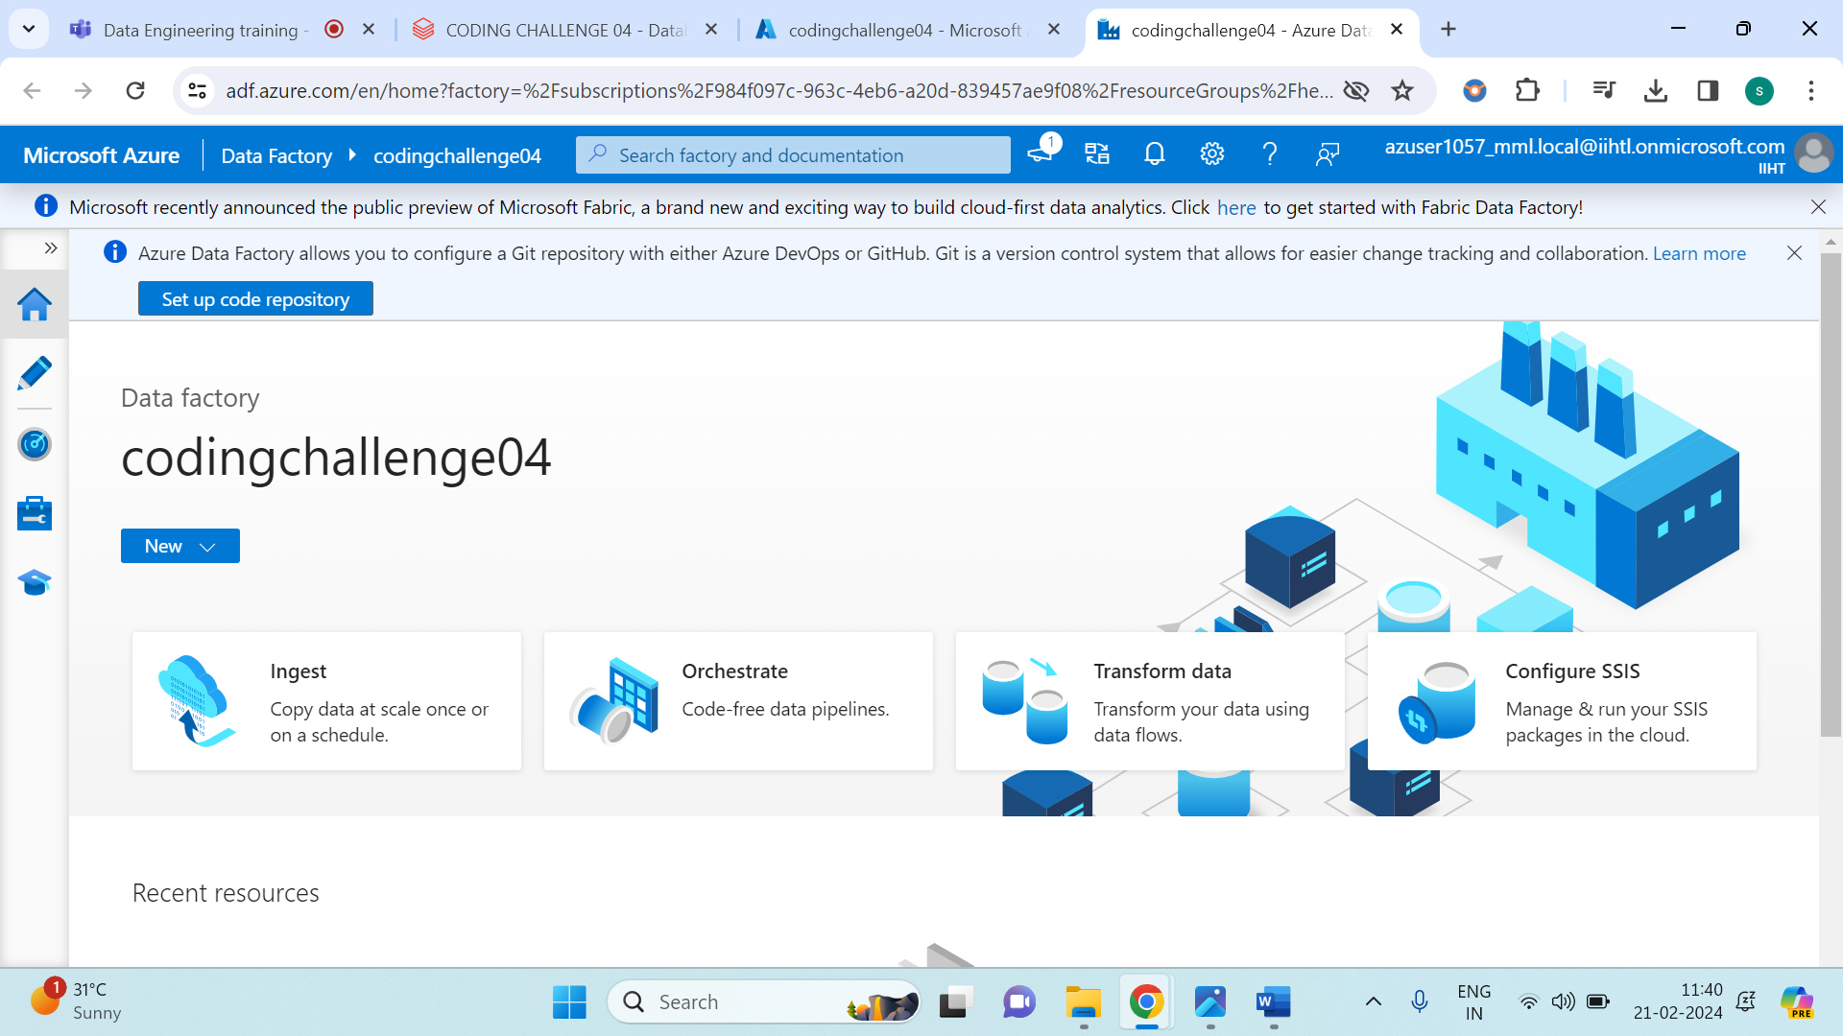

From the above image, select ‘Ingest’ .

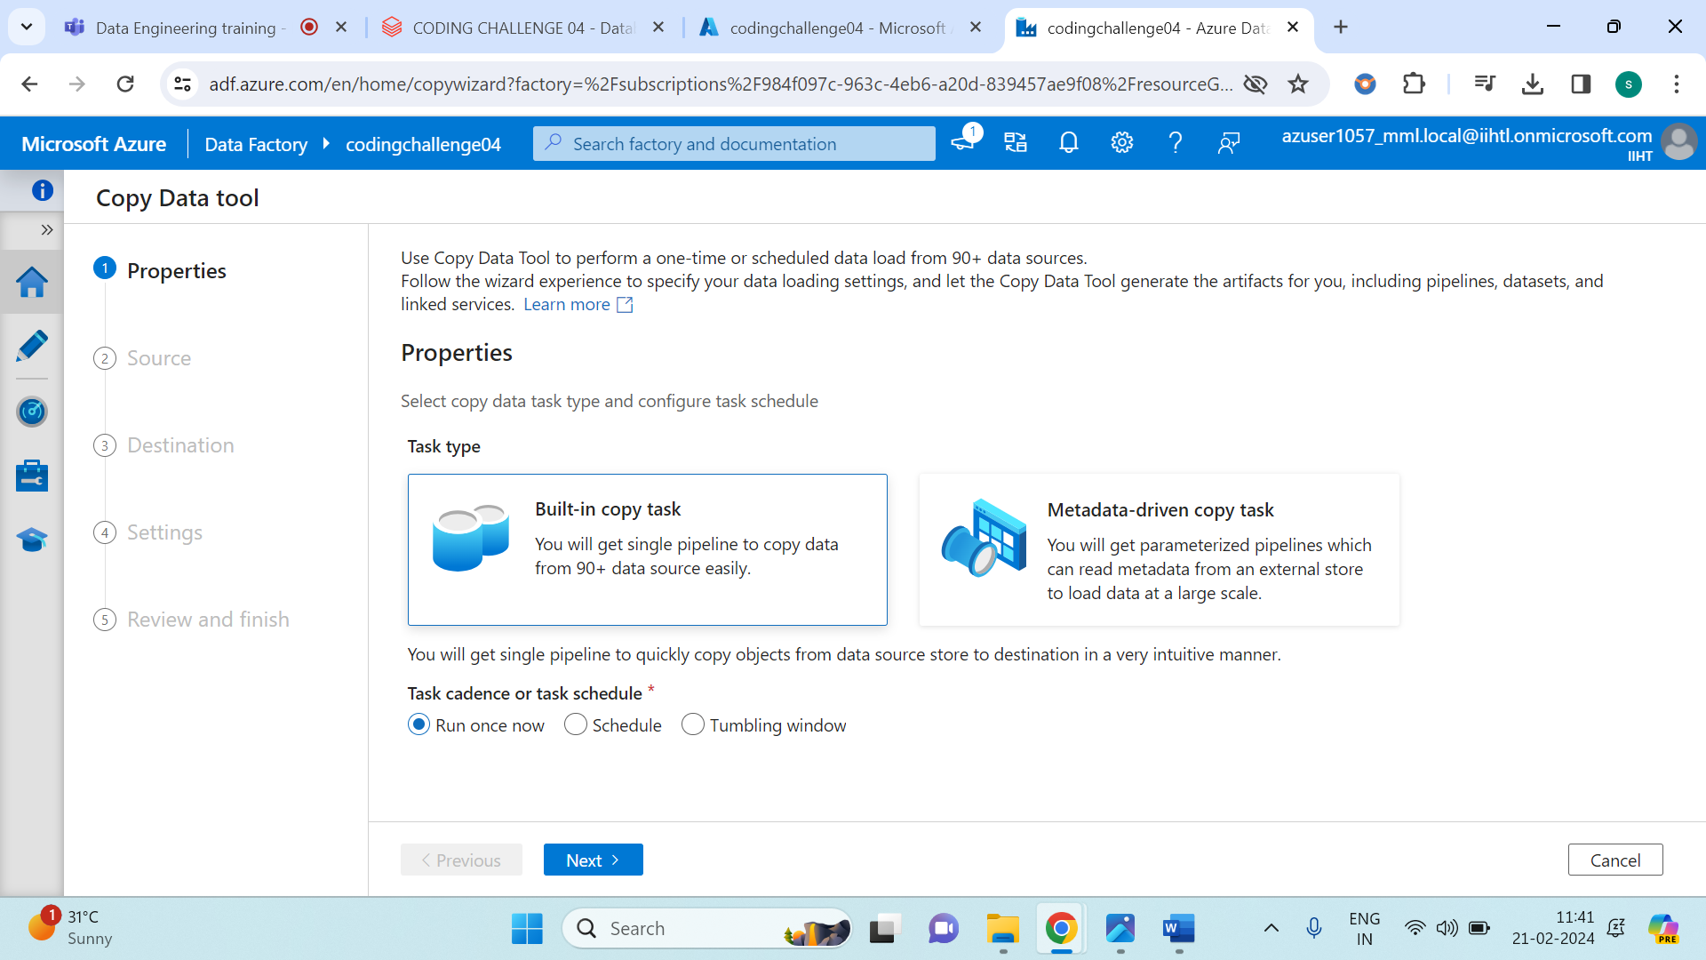

Click on next.

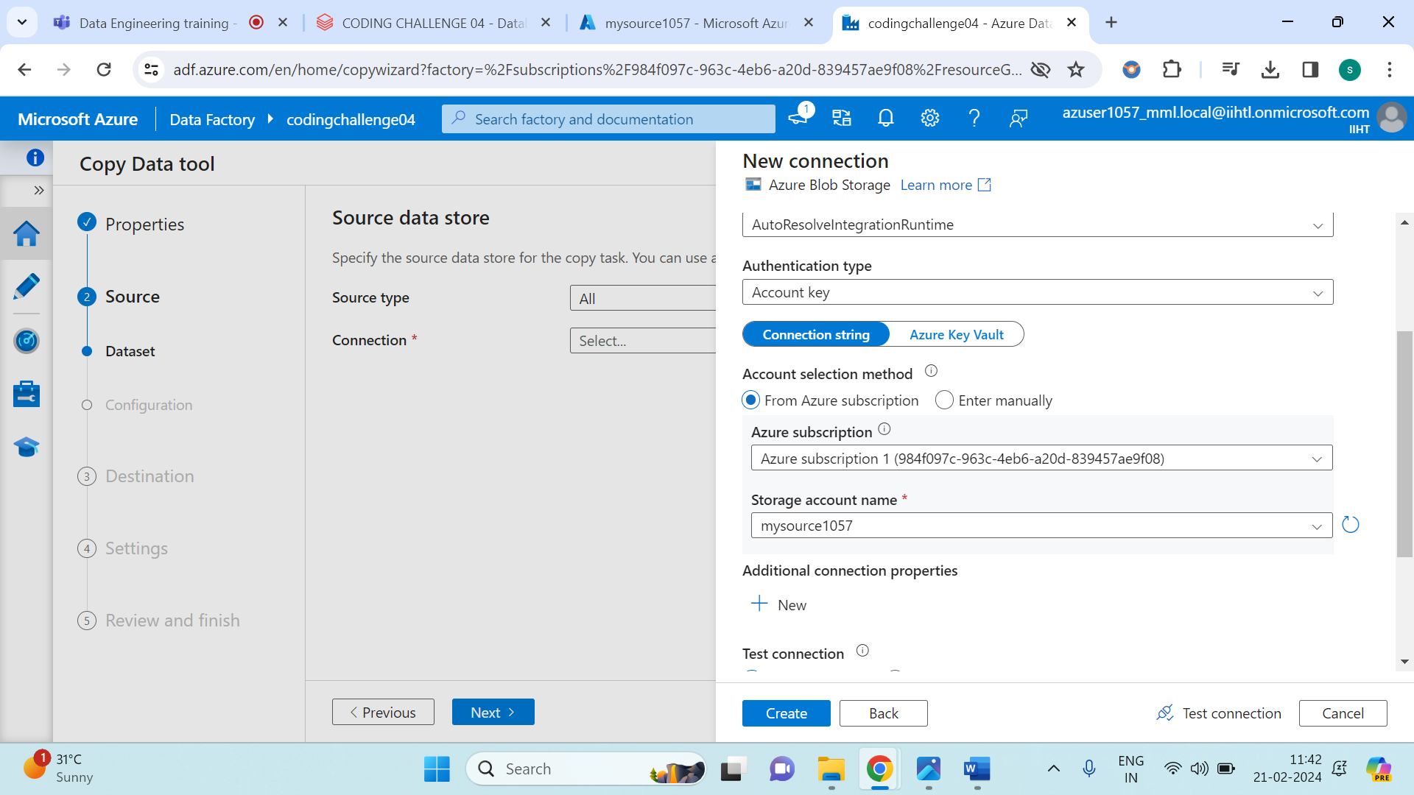

Mention your storage name and keep everything as same and click on next.

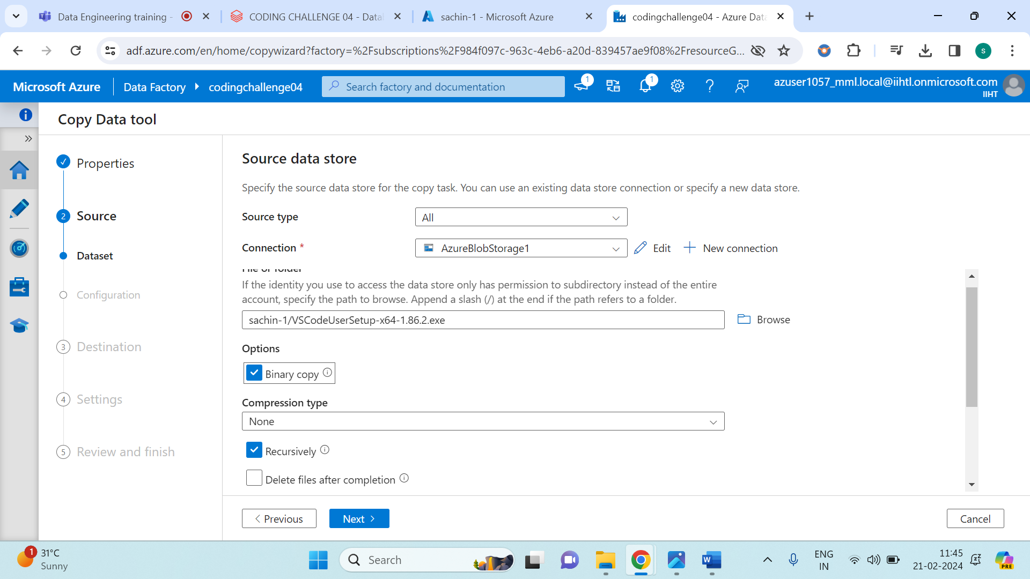

From the above image we need to browse the file select the application which you wanted to transfer and tick mark on ‘Binary copy’ and click on next.

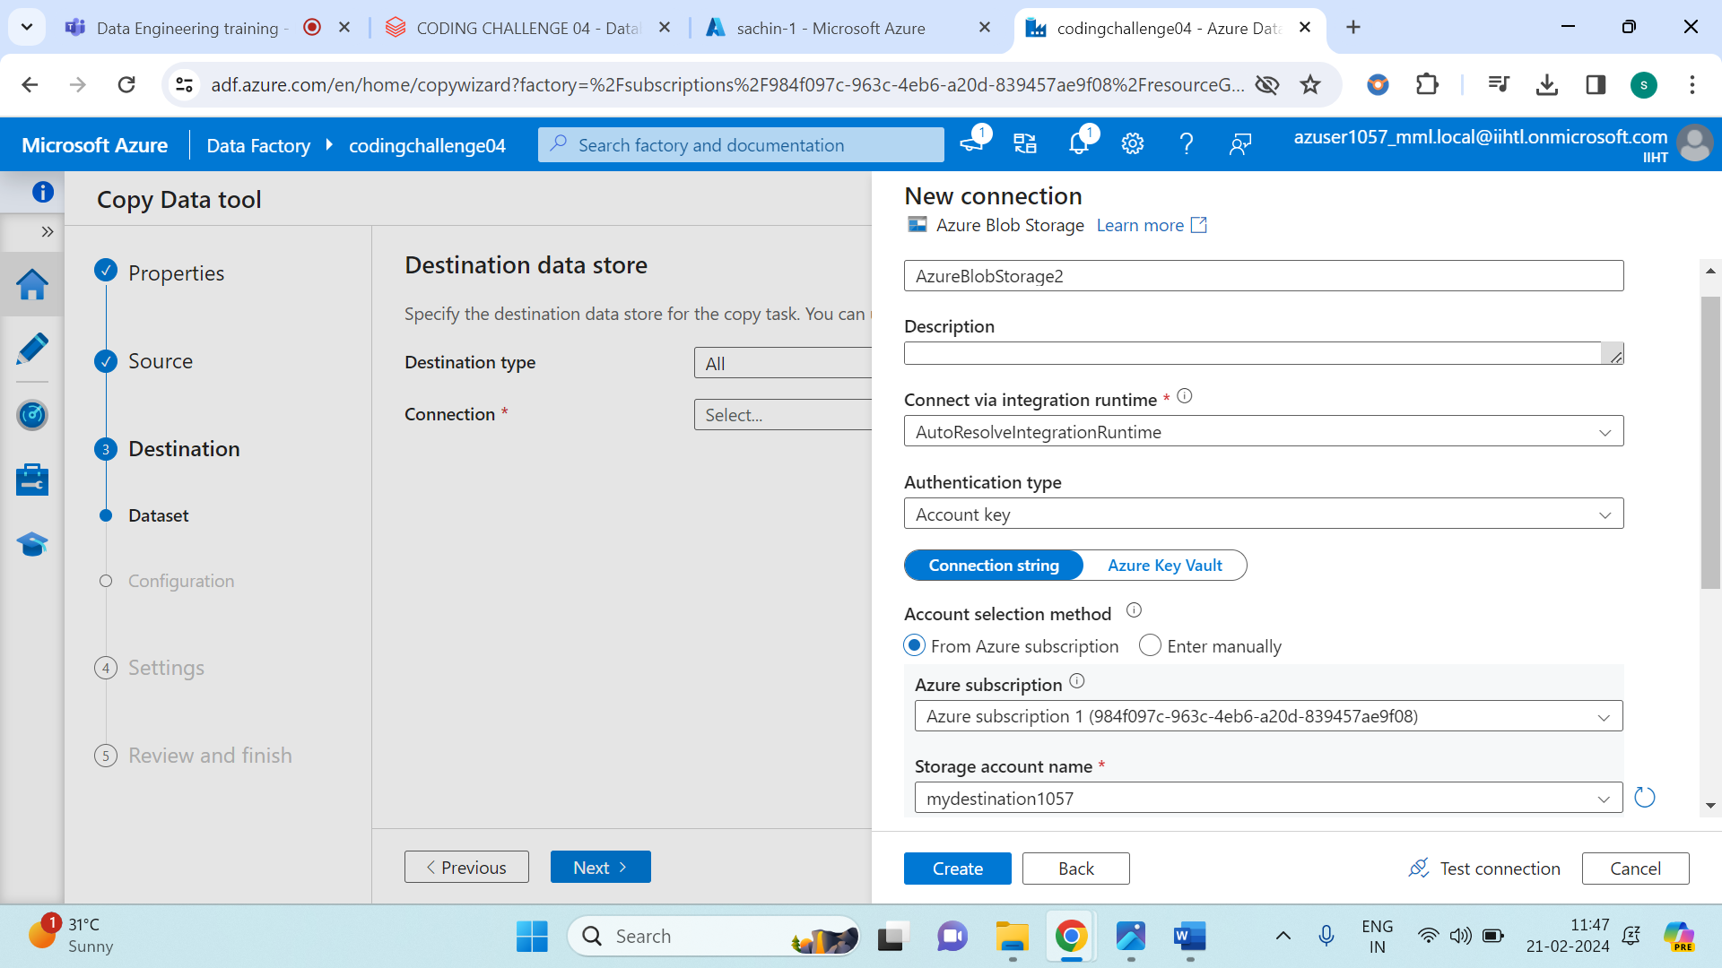

Give your storage account name in the destination data store and leave the rest and click on next.

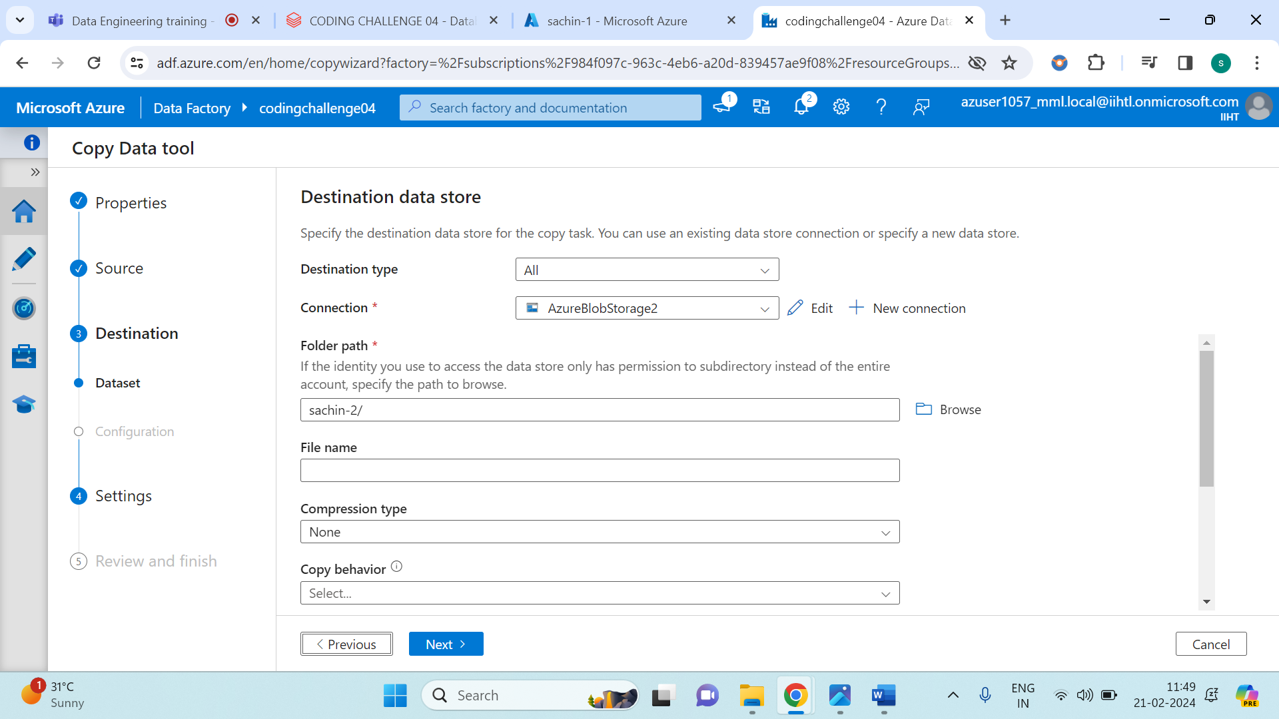

Browse your location of destination storage account.

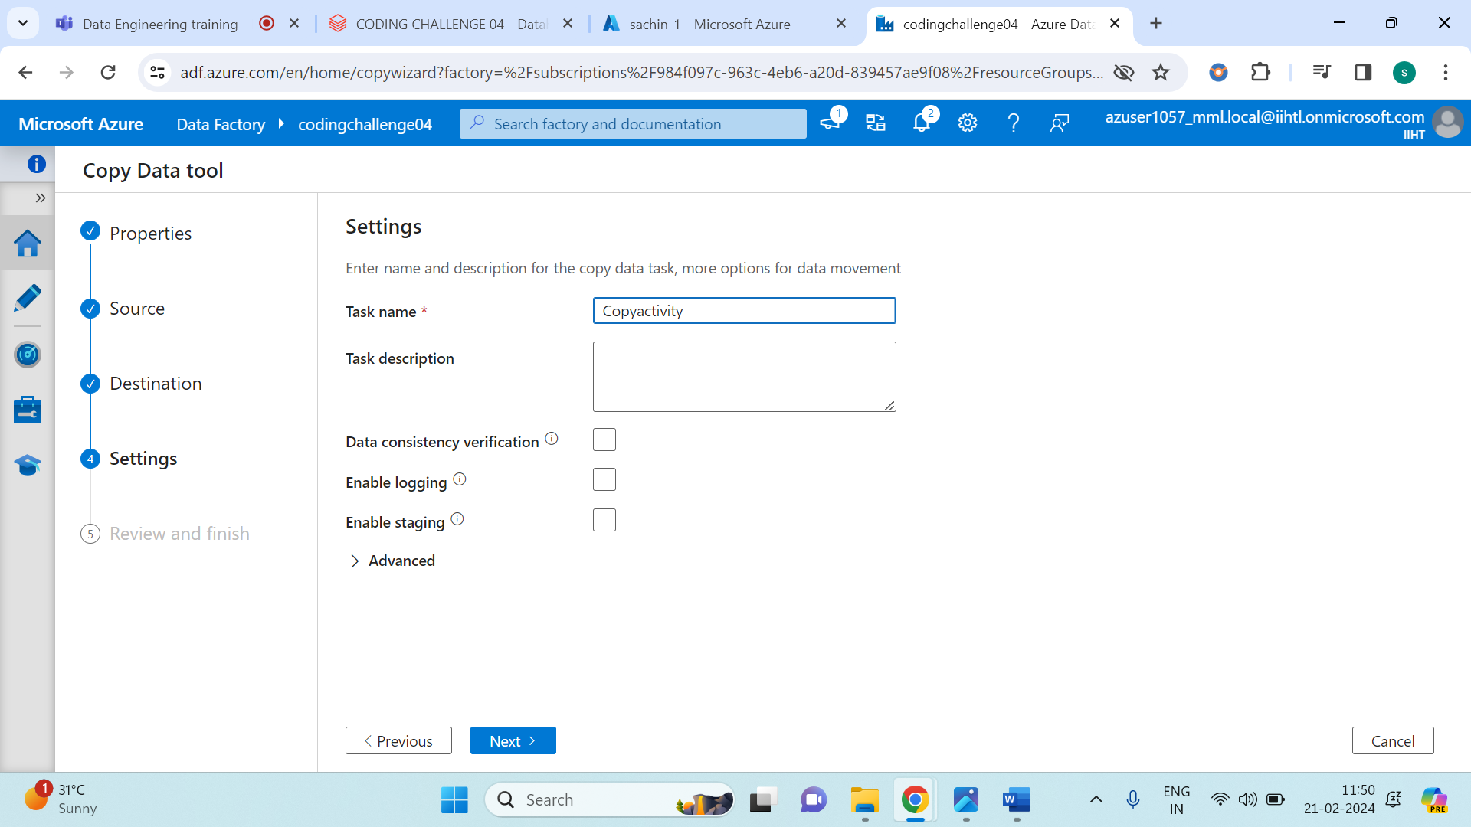

Mention a task name as shown in above image.

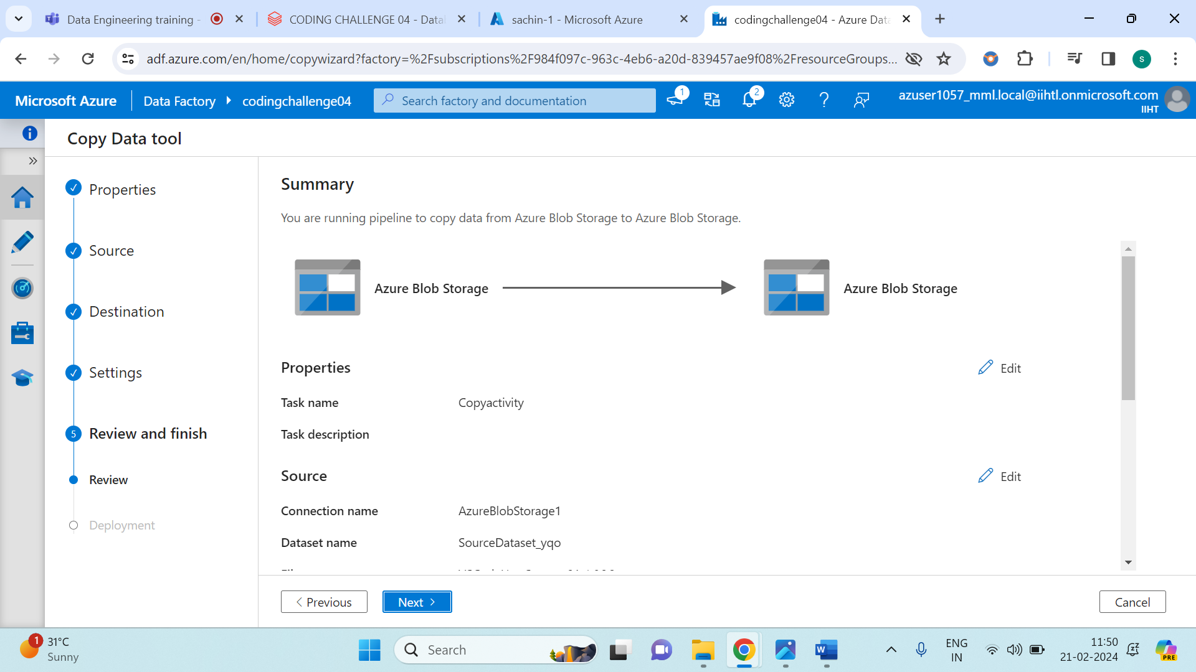

Check once if all are right and click on next.

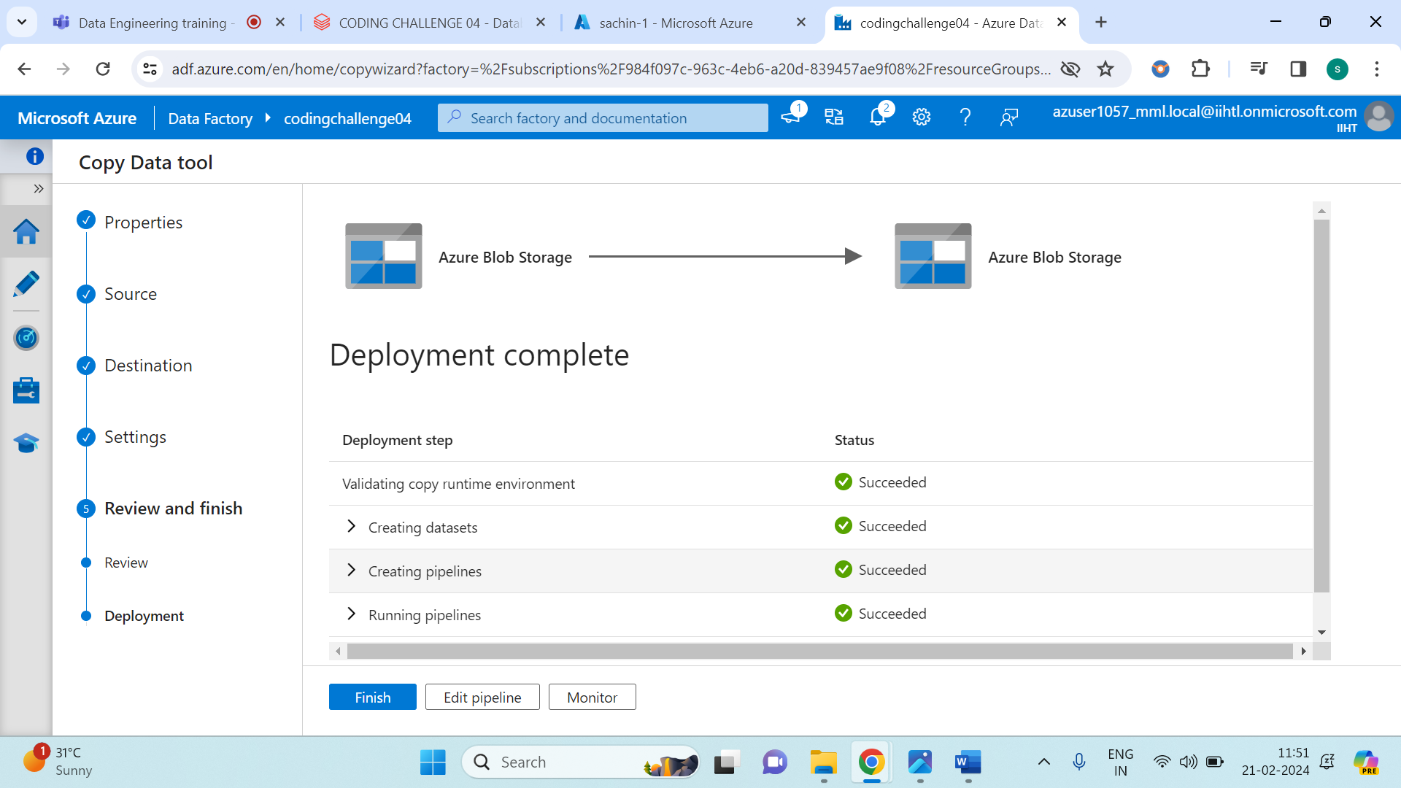

Click on monitor and the all set. Your task is done.

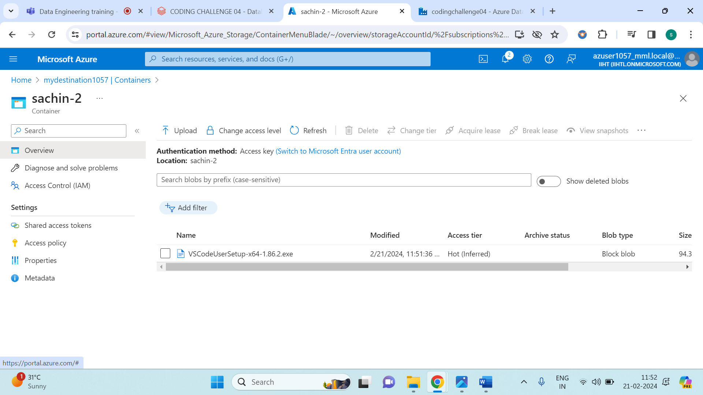

The above image shows us the application which was in **mysource1057** is successfully transferred to **mydestination1057**.

Overall, this shows us the **Copy Activity in Azure Datafactory (ADF)**.